

PROJECT AND TEAM INFORMATION

Project Title
Dynamic Disaster Risk, Evaluation & Rescue Optimization System

Team Name:  Team ID: | DisasterX  DSCPP-III-2026-T119
Team member 1 (Team Lead)  Gautam Parv  Student ID: 2510010701 2510010701@geu.ac.in | 
Team member 2  Kashish Rajput  Student ID: 251038891  251038891@geu.ac.in | 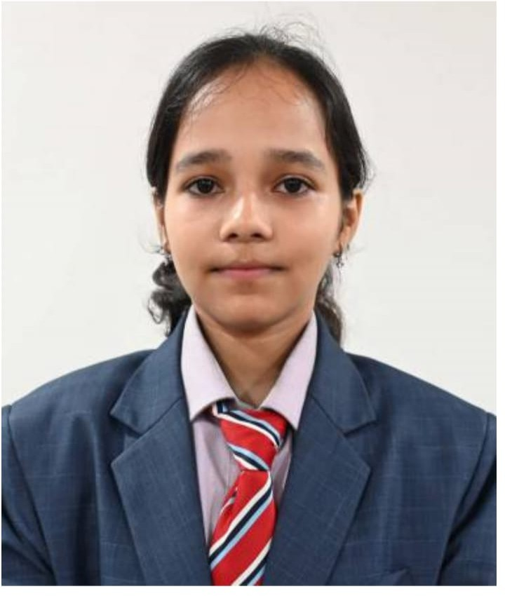
Team member 3  Harsh Raunchela  Student ID: 2510370071  2510370071@geu.ac.in | 
Team member 4  Piyush Maurya  Student ID: 2510202366  2510202366@geu.ac.in | 

PHASE-II PROJECT PROGRESS DESCRIPTION

Project Abstract
DisasterX is a system that helps rescue teams find a good route in a disaster. In floods and landslides, roads can get blocked or become unsafe. Then rescue teams cannot reach people on time. We use data structures, graph algorithms and machine learning to plan better routes and send the right help.
We show the disaster area as a graph. Places like villages, hospitals and rescue points are the nodes. Roads between them are the edges. Each road has distance, travel time, traffic, road condition and risk. We use these to find a good route. We made our own queue, priority queue, stack, hash map, set and min heap. We also wrote Dijkstra, A*, BFS, DFS and articulation points.
We also made a Python model using Random Forest. It tells us how risky each road is. Our C++ program reads these risk values and uses them when it picks a route.

Updated Project Approach and Architecture
In this phase we worked only on the main logic. There is no frontend yet. Everything runs from a menu in the command line, using C++.
The disaster area is a graph, and we store it as an adjacency list. Each place is a village, a hospital or a rescue point. Each road stores its distance, travel time, traffic, condition and risk. It also shows if the road is open or blocked. To test it, we used a CSV file with 500 places and 2,500 roads.
We did not use the ready-made containers from C++. We wrote our own data structures, like the queue, stack and min heap. We used them to write Dijkstra, A*, BFS, DFS and articulation points. These help us find routes, visit all places, and find roads that are very important for the network.
For the ML part, a Python Random Forest model gives each road a risk level. It saves the results in a CSV file. Our C++ program reads this file, and the risk level changes which route is best. The program also checks which emergency is more serious, chooses rescue help, and blocks or opens roads. After each change, it finds the route again.
The flow is simple: CSV file, then the Python model, then the C++ program, then the command-line menu. Next, we will test more and check the speed. We will add the database and map only if we have time.

Tasks Completed

Task Completed | Team Member
1. Graph and Dataset Implementation  Created the graph structure using an adjacency list.  2. Custom Data Structures  Implemented a queue, priority queue, min heap, hash map, set, and stack for emergency handling and resource management.  3. Graph Algorithms  Implemented Dijkstra, A*, BFS, DFS, and articulation-point detection.  4. Disaster Management Engine  Added emergency processing, rescue resource selection, road blocking and reopening, route decisions, and dynamic rerouting.  5. Machine Learning Integration  Developed a Python Random Forest risk-prediction module and integrated road-risk predictions with the C++ graph. | Parv Gautam  Harsh Raunchela  Harsh Raunchela  Kashish Rajput  Piyush Maurya  Kashish Rajput
  Piyush Maurya
  6. CLI and System Integration
  Developed the command-line menu to load data,
  Manage emergencies and resources, plan routes, and
  control Roads, and run the integrated simulation

Challenges/Roadblocks
We had a few problems while joining the data structures, the algorithms and the ML part.
First problem was road ids in the file were written wrong that’s why the road was not connecting.we fixed this by changing the ids to one format only. Second problem was we have to load data two times. We fixed that too.
The third problem was connecting python and cpp.The risk result wsa saved in csv file then to the graphs but names were wrong. We fixed the data code, checked the CSV file before loading it, and corrected the errors in the C++ code.

Tasks Pending

Task Pending | Team Member (to complete the task)
1. Testing the program with bad input to check.  2. Time and space of dijkstra, a*, bfs and dfs, plus timing runs on our dataset.  3 Retrain the ML model on more realistic data and recheck that it loads into C++.  4. Apply mentor feedback .  5. Final documentation. | Parv Gautam  Harsh Raunchela  Piyush Maurya  Kashish Rajput  All team members

Project Outcome/Deliverables
DisasterX is a C++ program that finds routes for rescue teams and manages emergency help, even when roads get closed. It sees the roads from the csv file than tell the risk and pick the safer road.
From the cli menu we can also add emergency and send help, and close or open road.we tested this while testing the whole program and it worked.
For now it is a cli prototype.

Progress Overview
Project is working fine all the main things work together the graph , data and the data structures.The cli menu works as well. Our first tests show that the main parts work well together.
Nothing important is left from the first seven stages. We still need to test edge cases, check how fast the algorithms are, and try the ML model with better data. We have not started the database, backend or map, because we wanted to finish the main part first.
Next, we will finish the testing, show the project to our mentor, and decide what extra things to add before the final submission.

Codebase Information
Repository Link: https://github.com/harsh-raunchela/dynamic-disaster-risk-rescue-optimization
Branch: main
Codebase Overview: The repo holds all the C++ code for DisasterX: the graph, our custom data structures, the graph algorithms, the disaster management engine and the CLI. The Python Random Forest risk model is in there too, along with its preprocessing config and the CSV datasets we use for testing and integration.
Important Commits:
- Set up the project and wrote the first version of the graph and dataset loading.
- Added the custom data structures and graph algorithms.
- Brought in Dijkstra, A* and articulation-point detection.
- Built emergency processing, resource dispatch and dynamic rerouting.
- Connected the ML road-risk predictions to the C++ routing engine.
- Created the CLI menu and the full disaster simulation.
We use the repository to track code changes and keep the project’s history in one place.

Testing and Validation Status

Test Type | Status (Pass/Fail) | Notes
1. Dataset Loading  2. Location ID Validation  3. Data Structures  4. Graph Algorithm  5. ML Prediction  6.C++ and ml Integration  7. Emergency Management  9. Resource Dispatch  10. Route Planning  11. Dynamic Rerouting  12.CLI Integration  13.Edge-Case and performance testing | Pass  Pass  Pass  Pass  Pass  Pass  Pass  Pass  Pass  Pass  Pass  Pass | Successfully loaded 500 locations and 2,500 roads from CSV files.  Normalized location IDs and verified source and destination references.  Tested the data structures working properly.  Tested Dijkstra, a*, bfs,dfs.  Trained the Random Forest ml model  Loaded prediction with c++.  Verified that higher-severity emergencies are processed first  Verified that the resource with the better priority value is selected  Generated a route between L001 and LOC_0010  Blocked LOC_0051 to LOC_0077 and verified that the system selected an alternative route  Tested dataset loadings, ML loading, route planning, road control, and the main menu  Broader Validation remains to be done

Deliverables Progress
The major deliverables of DisasterX have been implemented . The graph and The main parts of DisasterX are done: the graph and data, our data structures, the algorithms, the rescue engine, the ML model and the command-line menu. We still need to test edge cases, check performance, and try the ML model with better data. We also need to check the latest ML and C++ changes again. A database, backend and map may be added later, depending on our mentor.
The disaster management engine can prioritize emergencies, choose rescue resources, block and reopen roads, and recalculate a route when needed. The Python Random Forest risk model is done and connected to the C++ system. Through the CLI we can show dataset loading, risk prediction, emergency handling, resource dispatch and route planning.
What’s left is edge-case testing, performance analysis, and checking the ML model with more realistic disaster data. We also need to re-verify the latest changes to the ML and C++ integration. A database, a backend API and a map-based frontend are possible additions later, depending on what our mentor says and what the project needs.

